**A New Chronology for Shakespeare's Plays**

It is a commonplace that Shakespeare's lines become longer as his career unfolds. Nearly as familiar is how this aspect of his verse, particularly his lines' internal pauses as marked by punctuation, sheds light on his works' chronology. Such was the implication, early on, of *Remarks on the Differences in Shakespeare's Versification in Different Periods of his Life and on the Like Points of Differences in Poetry Generally*, a monograph published anonymously in 1857 but since identified as the work of Charles Bathurst. There he observes:

It must have been remarked by most readers of Shakespeare who are not very unobserving, that his versification, in respect of the cæsura, as it is called, or division of the pauses, differs most exceedingly in different places. This difference is not as between one passage and another, or one scene and another, but generally, and in its extremes always, as between one play and another; and it depends on the time of his life.

Echoing his title here, Bathurst correlates chronology and caesura, with Shakespeare's pauses revealing a veritable law of his verse: "in metre," he continues, "Shakespeare changed very nearly regularly and gradually, always in the same direction."[1]

More nuanced than such a law suggests, the story of this change is also much larger than Shakespeare. Readers who make their way through any anthology of Renaissance drama sense the differences in blank verse as the even beats and ten-syllable lines of the late 1580s give way to something less predictable early in the next century. Whether referring to this transformation as an "unscrewing" (George Saintsbury) or an "evolution" (Marina Tarlinskaja), scholars agree that iambic pentameter became less iambic, and less clearly pentameter, in a process that commenced within a decade of its establishment as the dominant vehicle for plays in London's commercial theaters.[2] Told many times and from various angles, the narrative of blank verse's transformation depends in part on the sensitive readings of individual phrases, lines, and speeches by such scholars as Tarlinskaja, George Wright, Coburn Freer, and Russ McDonald, to name only these.[3] Also crucial, however, has been evidence of a more panoramic nature: statistical information relating to meter and vocabulary and typically surviving in tables that haunt handbooks and the appendices of collected works.[4] Prominent among this genre of evidence is the metrical research of Ants Oras, who in 1960 published *Pause Patterns in Elizabethan and Jacobean Drama*, a ninety-page pamphlet that has enjoyed an outsized influence. Employed in attribution studies by such scholars as Brian Vickers, MacDonald P. Jackson, and Gary Taylor, Oras's examination of where pauses fell in the iambic pentameter of various works has also been cited approvingly in the Oxford *Middleton*, *The Quest for Cardenio*, and, perhaps most consequentially, the influential "Canon and Chronology" section of Oxford's *Textual Companion* (1987), where it has something like pride of place among the metrical tests consulted.[5]

Because Taylor's work in "Canon and Chronology" (hereafter the "Oxford chronology") serves as a standard guide to the "when" of Shakespeare's achievement, it seems worthwhile to recall his hope that "the next half-century will begin to map an order in [the] chaos" of what remains mysterious about Shakespeare's timeline.[6] Indeed, as recent research has deepened our understanding of literary production--and, crucially, collaboration--in the era, what Taylor calls "the way forward to a more sophisticated interpretation of stylistic evidence" seems both available and compelling.[7] Accordingly, the present essay seeks to contribute new information about the order of Shakespeare's works by revisiting and, where appropriate, modifying Oras's pause-pattern investigations. Owing to its scope no less than its nature, Oras's research is typically treated as a finished thing--a monument of sorts. As we demonstrate, however, original prosodic research and rigorous statistical interrogation of Oras's figures can help generate information unavailable to him. Drawing on such new data in this essay, we suggest plausible modifications to the Oxford chronology; we also provide a richer contextualization of iambic pentameter in the 1590s and early 1600s, and identify what is likely to be Shakespeare's first writing for the professional playhouses.

**Oras's *Pause Patterns*: Methodology and Influence**

Oras's *Pause Patterns in Elizabethan and Jacobean Drama: An Experiment in Prosody* was published in the University of Florida Monographs series in 1960. Its title is slightly misleading, as the pamphlet addresses continental and English writers, from Machaut and Marot through Marlowe and Massinger, who produced decasyllabic verse over a span of nearly three centuries. Oras's aim is to demonstrate historical and personal patterns in iambic pentameter by tabulating where punctuated pauses fall within its first nine syllables (punctuation after the tenth syllable is not counted). With almost two-thirds of its ninety pages devoted to figures and graphs, *Pause Patterns* can be said to emphasize evidence over interpretation, although Oras is insightful in his concise commentary on authors and eras.

Pauses can be counted in three different ways in Oras's tabulation; he labels these A, B, and C pauses. A pauses are those signaled by punctuation of any kind within a pentameter line (Oras counts short lines, but not their terminal punctuation). B pauses, a sub-group of the A pause, are so-called "strong" pauses within the line: pauses signaled by any punctuation mark other than a comma, including periods, question marks, colons, semi-colons, and dashes. C pauses are comprised of punctuation marks dividing "split-" or "shared" lines. Almost by definition, C pauses are a sub-group of the B pause: the punctuation dividing shared lines is invariably "strong" in nature, rather than a comma. To summarize, then; in Oras's methodology, A pauses are all pauses, B pauses strong pauses, and C pauses those that divide a line or lines amongst two or more speakers. All B and C pauses are also A pauses, with C pauses representing the smallest (because most heavily specified) of the groups.

Oras counted A, B, and C pauses for thirty-eight Shakespeare plays, adding the A and B figures as well for *Venus and Adonis*, *The Rape of Lucrece*, and the *Sonnets*. He also tabulated A, B, and C pauses for approximately fifty non-Shakespearean plays from the era, as well as major poems by these and other authors. Additionally, he provides figures for C pauses (and only C pauses) for 174 additional plays by a large number of seventeenth-century playwrights, from Chapman, Heywood, and Dekker through Shirley and Davenant. All of this data is presented in the appendix to *Pause Patterns*. Assigning each title a row in his appendix's tables, for example, Oras records the number of pauses in each position, followed by the total for each work. At the far right of the landscape-oriented page, he calculates the percentages for each pause position, rounding to one place after the decimal. Between these strings of figures, Oras also supplies an entry for "First Half" percentages--that is, the ratio of pauses falling in the first-through-fourth positions to those in the whole line minus the "middle" fifth pause--and an entry for "Even" percentages--the percent of pauses falling after even-numbered syllables (i.e. second, fourth, sixth, eighth). Finally, Oras provides line graphs in which each title's relevant pauses are represented as (in most cases) a slender but steep set of peaks and valleys.[8]

The clear exposition of his methodology and "exhaustive" analysis of hundreds of thousands of lines of verse lend Oras's study the air of the empirical.[9] Yet, as Oras was himself aware, his research--perhaps any such prosodic analysis--depends on a number of assumptions that qualify the findings. As even a casual student of metrics realizes, prosody is in certain respects as much an art as a science: experienced readers can and do disagree about what counts as syllable, not to mention a stress. Thus an eleven-syllable line to one scholar can seem perfectly decasyllabic to another. Such variability has obvious implications for the repeatability of a tabulation like Oras's.[10] Even more uncertain is the status of the text. Oras is careful to cite the editions he uses for his research; by and large, these are reliable facsimiles of the texts as they were first published. Yet we have learned too much about the conditions of early modern print culture to suppose that these texts represent anything like a direct recording of an author's practice in iambic pentameter: scribes, compositors, printers, and publishers can all be imagined as potential influences on, and even collaborators in the production of, the appearance of pentameter in these printed works. Anyone who opens the First Folio, for example, can soon find punctuation marks that seem misplaced, or superfluous; still other lines will seem to lack punctuation that grammar, logic, or clarity calls for.

Other influences are internal to the texts themselves: genre, rhyme, prose, characterological idiolect, and dramatic subgenres such as wit combats, declarations, and plays-within-the-play (including masques) all have a potential claim on the style of a work's verse.[11] To be considered, too, is the fact that a text may not represent a single "event" of composition, but rather reveal layers of continuation and revision. Last in what is admittedly an abbreviated list of qualifying factors is the dubious assumption that Bathurst made: namely, that patterns move inexorably in one direction. Authors can and do choose to modify their writing, as we are reminded by, among other plays, the Roman *Julius Caesar*--apparently written in the midst of dramas unlike it in many elements of style. Confronted by the lack of fit between what we suppose about the order of Shakespeare's late plays, and a seeming anomaly in the direction of various stylistic tendencies, Taylor proposed a "bend in the curve at about the time of *Coriolanus*."[12] Therefore if we are tempted to read pause-pattern data as a cardiogram (the analogy to this then-emergent technology occurred to Oras), we should be aware of its limitations.[13] Rather than an unmediated record of a single writer's single event of writing, a text may be a composite of many hands, and many times. It may also be shaped by unknown contingencies of form or occasion. To interpret Oras's findings without acknowledging their limitations is to ignore his own cautions, relayed in the study.

As we have seen, a number of leading scholars have employed Oras's research in their investigations into authorship and collaboration in plays of the era. Gary Taylor's recourse to Oras in the Oxford Chronology saw him reproduce Oras's A, B, and C pauses in separate columns opposite an ordered list of plays, and refer to Oras's "pause test" (sometimes "pauses test*s*," in the plural) in his discursive remarks on chronology and authorship. By and large these remarks use Oras to confirm the approximate position of a play: "Oras's pause test clearly places *As You Like It* in the period after *King John*"; "In Oras's pause tests it is later than *Henry IV* but earlier than *Othello*, but could be anywhere in between." What Taylor does not mention, although it is there to see in the presentation of Oras's data, is the discrepancy between the order implied by Oras's figures and the order of the Oxford chronology.[14] That is, 9 of the 38 plays that Taylor orders share an exact position with the chronology that Oras's A pauses suggest (Taylor names such pauses "the most reliable" because "the most comprehensive").[15] These are, in order: *Shrew*, *3 Henry VI*, *Richard III*, *King John*, *Julius Caesar*, *Timon*, *Lear*, *Macbeth*, *Kinsmen*. Many other plays fall within two slots of each other in the Oras A order and Oxford chronology; these 15 include *1 Henry VI*, *Errors*, *Love's Labor's Lost*, *Richard II*, *Romeo*, *Dream*, *Merry Wives*, *2 Henry IV*, *Much Ado*, *As You Like It*, *Measure*, *Othello*, *Pericles*, *Winter's Tale*, and *Cymbeline*.

Yet almost as many plays, 14, are separated by three or more places in the two lists, among them *Two Gentlemen of Verona*, *2 Henry VI*, *Titus Andronicus*, *Merchant*, *1 Henry IV*, *Henry V*, *Hamlet*, *Twelfth Night*, *Troilus*, *All's Well*, *Antony*, *Coriolanus*, *Tempest*, and *Henry VIII*. Of course, no "test" of any linguistic feature--whether run-on lines, feminine endings, or colloquialism in verse--should be expected to produce smooth, universally satisfying results. This is particularly the case, as we have seen, because so many factors, extrinsic and intrinsic alike, can affect the makeup of a literary text. At the same time, however, it is troubling that the Oxford chronology and the Oras data disagree to this extent. Some of the plays are quite divergent in their places: Oras's figures for "first half" pauses, for instance, would have us put *Troilus* seven places earlier than Oxford locates it, and *Merchant* seven places later; *Antony* is six places later in Oras, *Titus* six, and both *Two Gentlemen* and *Coriolanus* four places later than in the Oxford chronology. Added to this puzzle is the extremely unlikely positioning, in Oras, of *2 Henry IV* before *1 Henry IV*, and of *The Tempest* before *Pericles*--chronological placements with which few if any scholars would be likely to agree.[16]

Taylor's use of the Oras data formed the basis of the most sustained examination of the procedure to date: MacDonald P. Jackson's essay "Pause Patterns in Shakespeare's Verse: Canon and Chronology," published in 2002. There Jackson describes Oras's methodology and findings before submitting some of the figures to statistical analysis. Like Taylor, Jackson believes Oras's A pauses to be "the most reliable chronological indicator."[17] He therefore uses a software program to compare each play's A pauses with every other play's A pauses to produce "a matrix of 1640 Pearson product moment correlation coefficients"--essentially, a number indicating how close each play is, in terms of a mathematical profile generated from its A pauses, to all the other plays. For the reader's convenience, Jackson suppresses the decimal points in the results, which he presents by listing each play in the Oxford chronology, with its five closest matches in descending order. So, for example, Oxford's first play, *Two Gentlemen of Verona*, is closest to, in order: 2H6 9879; Tit 9870; R3 9838; Err 9807; 3H6 9748. (A play would have a perfect correspondence, or "1," to itself, and a 9999 to a play with almost exactly the same distribution of pauses, and so on). Jackson begins his discussion of these results by noting "The tendency for plays to be most highly correlated with other plays of roughly the same date is remarkably strong."[18] However, he acknowledges that his test produced correlations that diverge significantly from what the Oxford chronology would predict. He mentions six plays in particular: *The Merchant of Venice* (which his results would place later than Oxford); *Merry Wives* (later than Oxford); *2 Henry IV* (varied, but on the whole earlier than Oxford); *Troilus* (earlier than Oxford); *Othello* (earlier than Oxford); and *All's Well* (later than Oxford). Despite these divergences, however, Jackson concludes that his correlations "provide independent testimony to (1) the general rightness of the Oxford chronology, and (2) the extraordinary consistency of Shakespeare's metrical development."[19] While it is easy to agree with the second claim here, regarding the "consistency of Shakespeare's metrical development," there are enough discrepancies between Oras's data and the Oxford chronology to call some of its placements into question. In the remarks that follow, we seek to demonstrate places where the Oxford chronology seems in need of modification.

**Rhythmical Climates and Personal Style**

Oras offered his brief discursive analysis of pause patterns on the basis of numbers and charts he produced by hand. As he explained the rationale for presenting his data both visually and statistically, "since mere figures appeal very little to the imagination of humanists, including that of the present author, the series of pedantically mathematical ratios were converted into graphs which, it is hoped, will mostly speak for themselves."[20] Because the kind of graphs he drew serve as the best introduction to his findings, we will use them here to present various snapshots of changes to what Oras called the "rhythmical climate of the time," as well as the "personal style" of individual dramatists--styles which unfolded within, and must have helped alter, the rhythmical environments in which they labored. Initially, such graphs do indeed "speak for themselves"; eventually, however, the data will ask for statistical analysis at a higher level.

We could start by examining the major transformation to iambic pentameter during Shakespeare's career as it appeared in the verse of his contemporaries. The two sets of three graphs below illustrate the pause patterns in groups of non-Shakespearean plays from early, middle, and late during Shakespeare's time writing for the professional playhouses. The first row provides the discrete data for each play represented; the second presents the same data with confidence intervals of 95% and a trend-line demarcating the average. The first panels of these graphs feature information relating to *1* and *2* *Tamburlaine*, *The Spanish Tragedy*, *Edward I*, and *Summer's Last Will and Testament*.[21] Its pronounced emphasis on the fourth position is absolutely characteristic of blank verse during the first years of its employment in the professional playhouses. One could notice, too, how little variation there is between the various playwrights' profiles in these panels; this is represented, in the first panel of the lower row, by the narrow gray band of this graph's confidence intervals. As is familiar to readers, dramatists of this era tended to write rhythmically homogenous blank verse. Such becomes all the more clear when we turn to the middle graphs, which advance us ten years, and represent the pauses of Dekker, Jonson, and Marston in *Sir John Oldcastle*, *Every Man in His Humor*, *Every Man Out of His Humor*, *Antonio and Mellida*, *Antonio's Revenge*, and *Poetaster*, respectively. In contrast to the first graphs, these suggest more variation in the ways that playwrights composed blank verse. They also indicate that the regular emphasis on fourth-position pauses--averaging nearly 38% of the total in the 1588-92 sample--has dropped to around 24%, with a concomitant rise in the sixth (+4%) and seventh (+7%) position percentages. Moving to the third panels, we see that this momentum has continued.

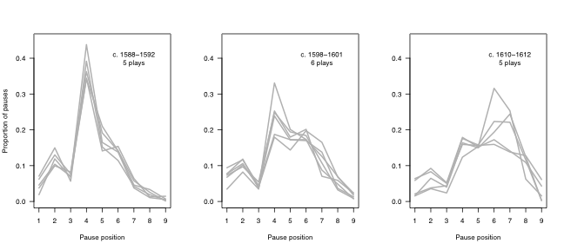

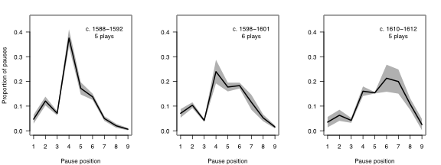

**Figures 1 and 2.** Aggregated pauses for three micro-eras of early modern plays. From left to right: *c.* 1588-1592 (5 plays); *c.* 1598-1601 (6 plays); *c.* 1610-1612 (5 plays). Bottom row repeats the data from the top; dark line indicates average, shading displays range. See text for author and titles.

The graphs for 1610-12, featuring writing by Middleton, Jonson, and Fletcher, summarize pauses for *The Lady's Tragedy* (also known as *The Second Maiden's Tragedy*), *The Alchemist*, *Catiline*, and Fletcher's portions of *Henry VIII* and *The Two Noble Kinsmen*. They show that pauses now come more regularly after the sixth and seventh positions than after the fourth. In fact, offering something like a mirror image of the pattern manifested a decade before, they confirm visually what Saintsbury called the "unscrewing," and Tarlinskaja the "evolution," of iambic pentameter from its somewhat rigid pattern of the late 1580s and early 1590s.

To be sure, playwrights could and did write verse that falls outside these era parameters. As Oras's figures suggest, and Jackson has discussed at more length, when Shakespeare collaborated on *Pericles* with George Wilkins, a younger and less experienced playwright, their writing differed in appreciable ways.[22] Wilkins wrote blank verse with the profile of an earlier era--*circa* 1599 rather than 1608, when they composed the play together. By that time, Shakespeare's style had developed closer to the pattern of the 1610-12 graph, above, than had Wilkins's. We can see the difference in the following graphs of the portions of *Pericles* typically ascribed to the two playwrights: Wilkins, acts 1-2; Shakespeare acts 3-5:

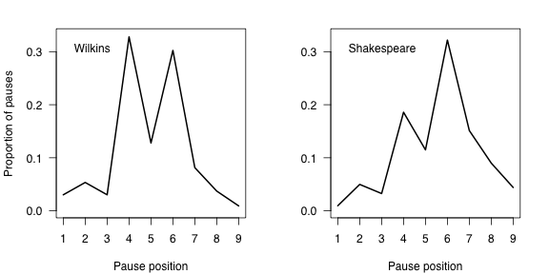

**Figure 3. *Pericles*' pauses, by author**. Wilkins, acts 1-2; Shakespeare acts 3-5.

As these graphs reveal, the majority of Shakespeare's pauses now fall in the second half of the line--with a higher number falling after the sixth, seven, eighth, and even ninth syllables--whereas Wilkins is balancing his pauses between the fourth and sixth syllables in a manner that more closely matches Shakespeare's writing in the late 1590s. It was probably the story matter of *Pericles* that led Jonson to deride it as a "moldy tale." Yet if anything about its verse rhythms seemed archaic, the fault lied not with Shakespeare but with his younger collaborator, who started the play in a metrically old-fashioned way.[23] Indeed, what we can learn by comparing these *Pericles* graphs with the year graphs in Figures 1-2, then, is that while identifiable norms existed in the rhythmical climate of verse composed for the commercial theaters, these norms were both dynamic and violable. Individual playwrights and plays could and did relate to them in various, sometimes divergent, ways, and sometimes (as with *Pericles*) during the same compositional moment.

Graphs of individual playwrights' composite pauses give us an idea of their stylistic habits, including the variation in their placement of pauses. We could preface our discussion of the information conveyed therein by pointing out that, while pause patterns are not necessarily predictive of the spoken emphases in texts commonly held to be constitutive of meter, in practice they are good indicators of such: works with a greater separation of percentages between even and odd syllables, with the higher number of pauses following even syllables, are invariably more regular in their meter. The six graphs below, arranged in roughly chronological order of the dramatists' productive years, demonstrate not only the transformation of blank verse in this era, but the various playwrights' idiosyncratic relation to the tendencies of the larger market in representation. The first graph represents three plays by Thomas Kyd: *The Spanish Tragedy*, *Cornelia*, and *Soliman and Perseda*. Kyd's pattern is like a ski slope in its steady descent from a majority of fourth-position pauses. In its lack of a sixth-position uptick--the mark of a more comprehensively iambic style--his graph best evidences the beginning stage of dramatic pentameter in this era. The next graph features six of Marlowe's plays: *1* and *2 Tamburlaine*, *The Jew of Malta*, *Doctor Faustus*, *Edward II*, and *The Massacre at Paris*. Were they to be separated from this composite, the patterns for the two *Tamburlaine* plays would resemble Kyd's template: a high fourth position followed by a progressively declining slope in the fifth-through-ninth. The uptick on the sixth in his composite figures is supplied by two plays apparently composed at the end of his life, *Edward II* and *Massacre*. It is likely, then, that the slight uptick on the sixth in Marlowe and Nashe's *Dido, Queen of Carthage*--written before the *Tamburlaine* plays--is attributable to Nashe, who revealed this more iambic tendency in *Summer's Last Will and Testament*. The third graph represents over two decades of pentameter by Shakespeare, hence its large field of variation. Evident in even such an expansive "time-lapse," however, is what Benedick would call the "even road" of Shakespeare's verse (*Much Ado*, 5.2.33-34). Whether allocating the majority of his pauses before the fifth position or after it, Shakespeare's tendency is to punctuate his units of speech after an even-numbered syllable. Yet although we think of him among the era's most fluid writers, two of his co-authors in the six works accepted or alleged to be Shakespearean collaborations-- *Edward III*, *Titus Andronicus*, *Timon of Athens*, *Pericles*, *The Two Noble Kinsmen*, and *Henry VIII*--display a greater percentage of pauses after even-numbered syllables: Peele, by a small margin, in *Titus Andronicus*, and Wilkins by a large percentage in *Pericles*.[24]

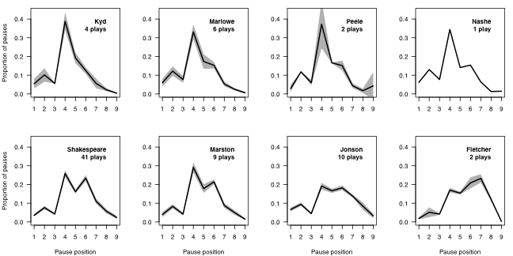

**Figure 4.** Pause profiles for eight authors.See text for titles.

The Marston graph features percentages for 8 plays, including *Antonio and Mellida* and *Antonio's Revenge*, *The Dutch Courtesan*, *The Malcontent*, *Parasitaster*, *Sophonisba*, *What You Will*, and *The Insatiate Countess*. Perhaps not surprisingly for a playwright who so directly imitated Shakespeare in his *Antonio* plays and in *The Malcontent*, his pause patterns are like the senior playwright's--however much the *sound* of his verse starkly diverges from Shakespeare's.[25] The next graph, for 10 of Jonson's plays, covers *Every Man in His Humour* (1601), *Cynthia's Revels*, *Poetaster*, *Every Man Out of His Humor* (1600), *The Case is Altered*, *The Tale of a Tub*, *Catiline*, *The Alchemist*, *Sejanus*, and *Volpone*. Even a quick glance reveals the material basis for the famously prosaic feel of his verse; although the fourth and sixth positions feature the largest percentage of his pauses, the fifth and seventh are not as greatly differentiated from them as in the verse of Shakespeare and Marston. Oras notes that this "unusual evenness" of pause distribution gives Jonson graphs the appearance of having "flat though firmly built roofs," with these lines' "final points so hanging in mid-air." That is, other playwrights' ninth-position pauses typically average a percentage point or less, making them seem to rest on the x-axis. In contrast, Jonson's--perhaps because of his attraction to split lines--are noticeably higher.[26] The final graph here is for Fletcher's portions of *The Two Noble Kinsmen* and *Henry VIII*. Member of a younger generation of playwrights, Fletcher in his verse demonstrates the gradual march of pauses through the second half of the pentameter line. These two plays reveal a peak at the seventh position, an unusual pattern not repeated elsewhere in his oeuvre.[27]

**Pauses Patterns and Chronology**

As has long been recognized, the movement of pauses in dramatic pentameter has clear implications for questions of dating and chronology. A play from the early 1590s is likely to possess a different pause profile than a play written a decade or more later. One can see a stark example of this in two plays based on the same content: the anonymous *True Chronicle History of King Leir*, thought to have been written in the late 1580s or early 1590s, and Shakespeare's *King Lear*, commonly dated to 1605-06. To compare their pause patterns, as in Figure [**X**], is to see a difference in stylistic eras. If we lacked any other information regarding when these two plays were written, the graphs here would suggest that *King Leir* is more likely to be a play from earlier in the playhouses' tenure: its graph most resembles Kyd's composite, with its steady decline from the fourth. With its higher sixth-position pauses, in contrast, *King Lear* "looks" like a Jacobean text.

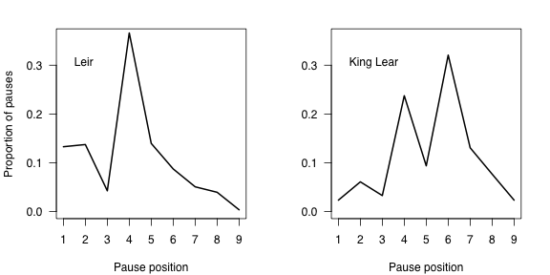

**Fig. 5.** Pauses in *King Leir* and *King Lear.*

We have already noted many aspects of pause patterns that give us reason for caution. Wilkins wrote atavistic pentameter that separates his style from Shakespeare's. Had we no other information about Wilkins's two acts of *Pericles*, we would be likely to misdate them if we relied purely upon their pauses. Yet even when such cautions seem foreboding, it is arguably a greater danger not to pursue information about the possible relation between style and chronology. If Bathurst's insight into the metrical progression of Shakespeare's verse is too confident when stated as a law, his claim about the larger chronology of pentameter has been affirmed by every scholar working on these materials. For example, a division of Shakespeare's dramatic output into thirds, based on received chronology, highlights the movement of pauses toward the end of his lines, shifting their majority from the fourth to the sixth (see Figure [X]).

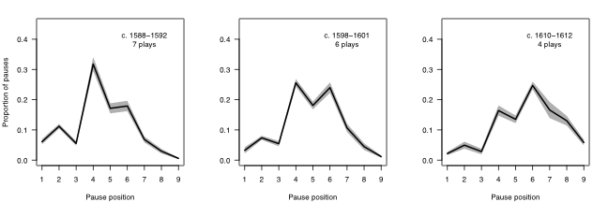

**Fig. 6.** Pauses in Shakespeare's plays: early, middle, and late. [cite titles by group.]

Even a glance at these three panels reveals what Bathurst alleged and many others have confirmed: there is a relation between *when* Shakespeare wrote and *how* his lines are structured. In the illustration above, this "how" is represented as a percentage of the punctuated pauses in his iambic pentameter lines. Can we use the idea of an "evolution," or, at least, a steady development, in Shakespeare's practice as a writer to place his works in a chronology? Doing so will require us to give Oras's figures more rather than less attention, interrogating them with an eye toward solving some of the puzzles they present.

Such an endeavor faces many obstacles. To begin with, the received order of Shakespeare's works is what social scientists call a "sticky" phenomenon: something fixed through custom, and hard to dislodge.[28] It says something about the power of tradition, for example, that both Oras and Jackson began and ended with chronologies not of their own devising. In setting out the Shakespeare figures of his 1960 study, Oras employed the 1930 chronology of E.K. Chambers, even though his own graphs and numbers contradicted the order that Chambers had posited.[29] Similarly, we have noticed that in his essay of 2002 Jackson used the 1987 Oxford chronology as his baseline, finding his statistical analysis to confirm its "general rightness" even though a half dozen plays seemed enough out of place for Jackson to discuss the discrepancy. In each case, the received version of Shakespeare's chronology appears to have been too sticky to be dislodged by the new data.

As we have pointed out, Oras did not generate a chronology from his research, even though his figures suggested obvious modifications to the Chambers timeline. A number of options existed, including sorting by the ratio of "first half" pauses, the "even" pauses, or some arrangement of his A, B, and C pauses. Had he made such an attempt, he would have needed to address the discrepancies between his results and the chronology he started with. We noticed, too, that a simple arrangement of Oras's figures would lead to some counter-intuitive placements: *2 Henry IV* would come before *1 Henry IV* in an ordering based on both "first half" and "even" pauses; *Antony and Cleopatra* would come apparently too late, and *The Tempest* earlier than we think it was written. Ideally, then, a chronology based on Oras's figures would need to address whatever in them led to such counter-intuitive placements. It would also need to incorporate the most recent state of knowledge concerning Shakespeare's collaboration with others, employing Oras's methodology on the parts of texts that scholars believe Shakespeare wrote. Finally, such a chronology would be buttressed by a statistical test or tests to analyze both the interrelation of the pause data and its movement over time. In the following section, we present a new chronology for Shakespeare's plays based on just such a series of procedures.

**Correspondence Analysis and Shakespeare's Chronology**

Oras's figures suggest a seemingly straightforward procedure for ordering the plays: simply record where a particular texts fits into an ascending or descending row of figures. While straightforward, however, such ranking goes against the complexity of the data. To address the differing number of pauses in various texts, for instance, Oras quite understandably made them equal by converting their pauses to percentages. But while this commonsense solution solves one problem, it creates another, as plays (and parts of plays) vary greatly in the amount of data they offer. Thus treating the shortest Shakespeare text in the sample (in this case, his contributions to the lightly-punctuated *Sir Thomas More*, with a scant 32 pauses) as statistically equivalent to his most pause-heavy text (*Cymbeline*, with 2,735 pauses) emphasizes the former at the expense of the latter. Making their pause data equal 1, that is, imposes a statistical constraint on them both, and implies equal confidence in how representative their information is. Because texts offer varying amounts of data, it is suspect to use equivalencies for relational assessments. Thus the element of Taylor's Oxford chronology that looks to Oras for confirmation, and to a certain extent Jackson's more statistically sophisticated analysis of that chronology, rely on an artificially constrained data. How, then, to acknowledge the differential weight of the Oras-type data?

A valuable method for comparing compositional data--including multivariate data--is correspondence analysis (or CA). At its most basic, correspondence analysis is a computer-intensive, statistical methodology that takes categorical information and looks for associations, and strength of associations, in the relations of rows (where its various objects and assemblages are listed) to columns (where such variables as, for instance, time, location, and income, among others, may be recorded). Correspondence analysis first attempts to identify, and then rank, the most statistically significant variation in that data. Thus the first correspondence analysis axis will account for the largest amount of variation in the original data, the second axis will account for the next largest portion, and so on. By identifying the most crucial of these variables, researchers can visualize and interpret the bulk of the variability in any original data. For this reason correspondence analysis as well as a related methodology, principal component analysis (PCA), are known as *dimensionality reduction methods*, meaning they reduce the complexity of a set of data by boiling it down to a few axes of major importance.[30]

Adopted widely across the natural- and social sciences, correspondence analysis has been employed for a variety of research purposes.[31] Germane to our purposes here is the extensive, and sophisticated, use of correspondence analysis in seriation studies. Seriation, or simply "putting things in order," is usually an exercise in relative dating, employed when an absolute dating method may be unavailable. In the field of archeology, for example, researchers are often confronted with artifacts that only occasionally have information regarding production or use attached to them. When carbon dating or information relating to, say, tree rings or chemical composition is unavailable, archaeologists have refined the statistical bases of correspondence analysis to help them order, and thus date (however approximately) things of uncertain origin. By comparing the known composition of pottery remains, for instance, archeologists may place certain assemblages closer together in time based on how similar they are to one another.[32]

Shakespeare's plays may not strike us as artifacts, of course, but the procedures of correspondence analysis as refined for seriation nevertheless provide a statistically rigorous methodology for examining their material components.[33] On the basis of such an examination, in fact, we can offer a tentative chronology that responds to the differential distribution of features--in this case, pauses as recorded in the verse of early texts--throughout the canon. This chronology should be understood as a provisional timeline of *when the iambic pentameter in the play texts under examination was largely composed*. By this last, we mean to call immediate attention to the likelihood that some of Shakespeare's plays were written at one time (even over various times) and revised at another, or others. A play title thus need not connote an event, but may sometimes have been multiple events, even a process. The fixity of any ordering, then, needs to be qualified in the context of diachronic composition.

Our next two illustrations introduce the preliminary results of two statistical procedures: a principal component analysis (PCA) and a correspondence analysis (CA), respectively, with results from both procedures displayed, left to right, in each graph. Given our nine discrete categories of pauses, it would conceivably be possible to map out the position of each play text (and, in the case of collaborative work, of each relevant part of a play text) in nine dimensions. For ease of interpretation, the two pairs of biplots below (in Figures 7 and 8) map the Euclidian distances among the data in two dimensions. The panels of Figure 7 plot the pause data as arrows in relation to the first two axes of variation, with the most important variation on the horizontal axis (the dashed line bisecting the square horizontally), and the second most important variation on the vertical axis (the vertical dashed line). The left panel represents principal component analysis (PCA). One could note that the foremost variation, labeled PC1 on the x-axis, is mostly capturing variation in 4th, 6th, 7th, and 8th position pauses (looking at how far each arrow travels left-right--that is, along PC1--those arrows reach the farthest). For its part, PC2 (labeled on the y-axis) is mainly capturing variation in 4th, 7th, 2nd, and 8th positions; again, one could notice far up or down each arrow goes to gauge its contribution.

The patterns are broadly similar in the correspondence analysis (CA) panel on the right-hand side of Figure 7. Yet now the 4th position arrow, although slightly shorter, is more closely aligned with the horizontal plane. This means that changes to pauses in the 4th position contribute a great deal to the primary axis of variation (CA1) in our correspondence analysis, but hardly at all to the second most important (CA2). Similarly, 6th position pauses are contributing somewhat to CA1, but mostly to CA2.

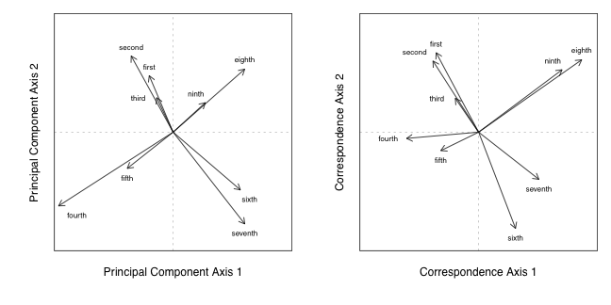

**Fig. 7.** Plots illustrating the contribution of each pause type to the first two axes of variation for principal component analysis (PCA) (left) and correspondence analysis (CA) (right). The direction of each arrow indicates to which axes each pause position contributes, and in what direction, while the lengths of the arrows indicate the strength of each pause type's contribution.

Our next illustration, Figure 8, maps the data derived from the principal component analysis (PCA) and correspondence analysis (CA) described by the previous figure. Figure 8 indicates the position of each text and relative distance from other texts in a two-dimensional rendering of Euclidian space.

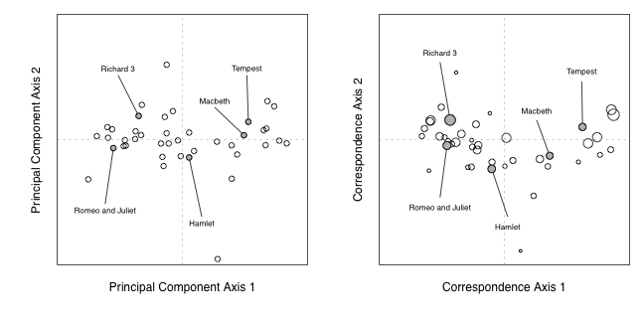

**Fig. 8.** Plots illustrating the first two principal component analysis (PCA) scores (left) and correspondence analysis (CA) scores (right) for 41 Shakespeare texts. Each point represents an individual text; distances among texts reflect differences in pause position composition. In the CA plot, the size of each point represents the weighting assigned to each text in the analysis. The same five titles have been highlighted in each plot.

One can interpret the position of the play points by looking back at the axes of variation in Figure 7. Texts are positioned in relation to where pauses occur in their pentameter lines, and in what proportion. For example, plays like *Romeo and Juliet* and *Richard III* have relatively more pauses early on in lines (i.e., at positions 1 through 5), while plays like *Macbeth* and *Tempest* have more late-position pauses (6th through 9th). The circles in the right-hand panel in Figure 8 (the results of the correspondence analysis) have been scaled to reflect the relative weights of the data: plays with low total pause counts appear as slightly smaller circles; those with more pauses appear as larger circles. This is one advantage of correspondence analysis: as opposed to principal component analysis, correspondence analysis allows one to recognize differences in the amount of data contributed.

Such is worth pointing out because in most statistical analyses it is desirable to describe not only average patterns, but variability as well. In studies where researchers can return to a population and resample it, they may gain powerful insights. However, we have only one set of counts for each play, just as an archaeologist may only have one set of pottery fragments from a given location. To understand how small differences in our observed data may influence the outcome of our analysis, therefore, we employed a "bootstrap" method. This too has a long history of use in archeological studies (Ringrose 1992). The bootstrapping procedure is essentially a method of resampling. When one cannot resample from the population of interest, one resamples from the data available. In our case, that means taking random samples of pauses from each play and re-running our correspondence analysis using the new values (Lockyear 2012, Peeples and Schachner 2012). We retain the same sample size for each play, but we sample with replacement (meaning some pauses from the original data will be sampled more than once, and others not at all); this results in new counts of each pause type that vary slightly from the original counts. We repeat this resampling 1000 times, performing the correspondence analysis with each new set of counts. This affords us some measure of uncertainty for our correspondence analysis scores--"uncertainty" in this case being a desirable thing, as it can suggest confidence intervals for the results.

Figure 9 displays the results of a bootstrap procedure for 39 of the 41 texts treated in our correspondence analysis. Results for the *Sir Thomas More* pages and the Additional Passages to the 1602 *Spanish Tragedy* have been omitted; because these texts feature so little data, their oversized convex hulls (the shaded polygons representing each title) awkwardly dwarf the chart. As an illustration, we would note that the text with the next fewest amount of pauses, *The Merry Wives of Windsor* (with 240), is responsible for the large polygon in the lower center of the chart: because it has less information to analyze, a bootstrapping procedure repeated 1000 times produces considerably more variation. The polygons for the remaining 38 texts, however, trace a gradual arc up and to the right. We have called out five canonical texts--from *Richard III* and *Romeo and Juliet* through *Hamlet*, *Macbeth*, and *The Tempest*--to show how this data reveals the chronological progression of Shakespeare's works.

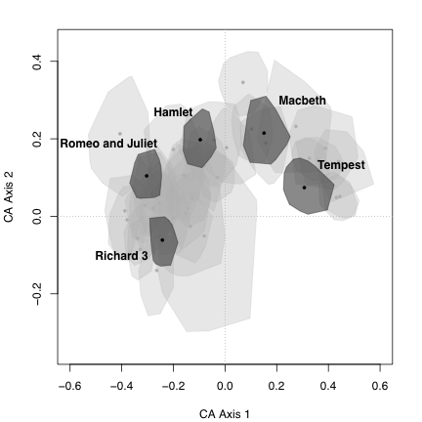

**Fig. 9.** Bootstrapped data for Shakespeare's plays. **(**Not shown: *Sir Thomas More* (selections); Additional Passages to *Spanish Tragedy* 1602.)

The "crescent" of Shakespeare's verse pauses also provides a basic template for understanding the syntactical development of his contemporaries' iambic pentameter. Figure 10, for example, charts the pause profiles of the six contemporary playwrights examined earlier (see Fig. 4) over and against those of Shakespeare's works (from Fig. 9, shaded light gray). We can see, in the plays of his contemporaries, the general movement plotted by his verse, from Kyd and Marlowe through Fletcher, with Jonson's less iambic practice (bottom row, center) demarcating him as an exception. We should note that Marston's polygons fall almost entirely within Shakespeare's, a result that is not surprising, given the fact that Marston began and ended his career as a playwright while Shakespeare was still working, and appears to have fashioned his plays (including the *Antonio* plays, and *The Malcontent*) strongly in response to the senior playwright's.

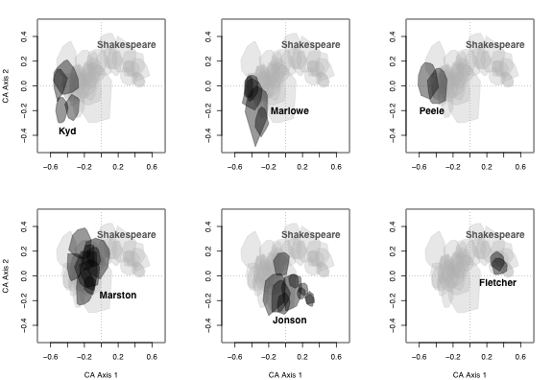

**Fig. 10.** Bootstrapped data for Shakespeare and six contemporaries. See Fig. 4 and text for titles.

Correspondence analysis, we should point out, provides relative ordering: object X most likely comes before, or follows, object Y, at Z distance. Not being content with simply obtaining a relative chronological order, we were interested in using external evidence about the plays to make explicit date predictions for each play. An extension of correspondence analysis called "constrained correspondence anlaysis" (CCA), allows us to do just that (Groenen and Poblome 2003). By incorporating such information as interval constraints for Shakespeare's career, as well as exact dates for some plays, and upper and lower limits on dates for others, we can constrain the calculation of the correspondence analysis scores (van de Velden et al. 2009). As we saw earlier, correspondence analysis produces only a single score for each play. The same is true of constrained correspondence analysis. We opted, again, to employ a bootstrapping procedure, which allowed us to not only estimate exact dates for each play, but to generate confidence intervals around those estimates. In this manner we were able to produce a revised chronology of Shakespeare’s plays, using only interval constraints, a few dates, and the pause position data itself.

To constrain our correspondence estimates, we assigned numerical values to three plays for which plausible dates could be suggested: 3 *Henry VI*, last quarter of 1591 (= 1591.75); *Julius Caesar*, first quarter of 1599 (= 1599.25); *King Lear*, beginning of 1605 (= 1605.0). Scholars could argue over these designations, of course, and other plays and dates could have been employed; these seemed among the more reasonable of our options. In addition, we set upper and lower bounds on the extent of Shakespeare's writing career, demarcating it from 1589.5 to 1614.0. While these boundaries are also open to debate, it seemed to us that they are defensible so long as they are understood to be judgements rather than facts.

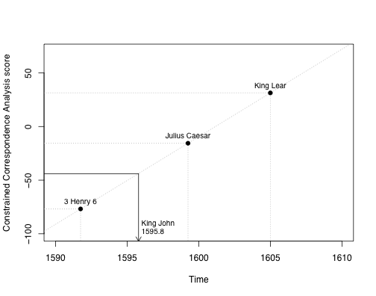

**Fig. 11.** Illustration of constrained correspondence analysis (CCA), modified from van de Velden et al. 2009. *King John* is dated using three "anchor" plays (indicated along the diagonal) as constraints. The regression between CCA score and time may be used to predict dates for the remaining plays. See Groenen and Poblome (2007) and van de Velden et al. (2009) for a full description of the method.

Figure 11 illustrates how constrained correspondence analysis (CCA) works: the relative positioning of an object (in this case, a text) is made concrete through the addition of specific information regarding other objects in the timeline. Thus *King John* is assigned a date of 1595.8, or October of 1595, as a manifestation of its statistical distance from 3 *Henry VI*, *Julius Caesar*, and *King Lear*. Obviously, the accuracy of such a "forcing" method depends on the soundness of these anchors, yet the procedure has the advantage of providing a specific date, rather than relative position, for each play.

Using a modified version of code from Poblome et al. (2009) we performed the constrained correspondence analysis (CCA) and subsequent bootstrap analysis in MatLab, a software program dedicated to numerical analysis. We present the results in two ways. First, in Figure 12, we show how the predicted dates fit with the Oxford chronology dates. The diagonal line rising from bottom left to top right indicates the Oxford chronology (which does not include, we should point out, *Edward III* or the Additional Passages to *The Spanish Tragedy*). The circles represent play texts, the lines the confidence interval of the data. To see where a play falls in relation to the timeline, one can draw a horizontal line through the center of its circle back to the diagonal. For some plays, it will be seen, our prediction falls earlier than the Oxford date (e.g. *Troilus and Cressida*, *As You Like It*); in other cases it is later (e.g. *Coriolanus*, *The Winter’s Tale*).

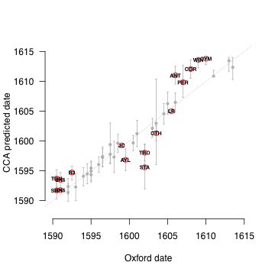

**Fig. 12.** CCA results plotted against Oxford Chronology*.The diagonal dotted line indicates the Oxford Chronology (which does not include *Edward III* or The Additional Passages to *The Spanish Tragedy*). Vertical bars represent texts; those above the line suggest a date later than the Oxford Chronology; those below it, an earlier date.

Figure 13 illustrates three chronologies: from left to right, the Oxford chronology; the correspondence chronology (CA); and the constrained correspondence chronology (CCA). The latter two are based, once again, on Oras's pause data, and on new pause data provided for collaborative works.

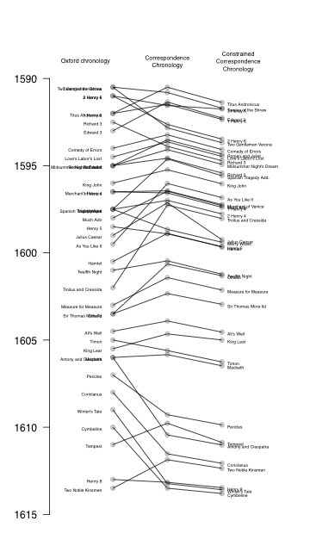

During the drafting of this essay, we gained access to new data: the metrical tables of Marina Tarlinskaja's book project, *Shakespeare Among Others*. There Tarlinskaja provides a massive collection of prosodic information on numerous playwrights, including Shakespeare. With Tarlinskaja's permission, we ran a principal component analysis (PCA) on the Shakespeare data, which does not include various prose-heavy plays (including *Merry Wives*, *Much Ado*, *As You Like It*, and *Twelfth Night*), or two collaborative works (*Sir Thomas More*, *Timon*). Further, Tarlinskaja offers only partial data for *Edward III*, so we chose to omit it. That left a total of 34 texts, with over 1,500 pieces of data regarding 45 stylistic and structural categories.[34] Because these figures are rendered largely in percentages, the concerns we have about Oras's artificial constraints on the data obtain here as well. Yet the information struck us as too valuable to go unaddressed. We wish to emphasize that the results are purely our own, rather than Tarlinskaja's, who should not be assumed to endorse any of the datings we adduce from analyzing her data. Further, our analysis of her figures assumes the same intervals for Shakespeare's career (1589.5 to 1614.0) as in the constrained correspondence analysis (CCA). We record a principal component analysis of her figures in Table 1, below, following, respectively, dates from the Oxford chronology, our constrained correspondence analysis of the Oras data, and the Brainerd figures. Following the principal component analysis of the Tarlinskaja data is a column with our CCA figures adjusted for playhouse closures--essentially, the results of a hand fitting of the data to some known contingencies. Bolded figures represent differences of a year or less centering on the Oxford data; italics indicate second-order correspondences. The three asterisks in the CCA column flag the dates that we provided (for *3H6*, *JC*, and *LR*, respectively), rather than data generated from analysis.

|  |  |  |  |  |  |  |
| --- | --- | --- | --- | --- | --- | --- |
| **abbrv** | **Oxford** | **Riverside** | **Bruster-Smith CCA** | **Brainerd** | **PCA Tarlinskaja** | **abbrv** |
| **SHR** | **1590-1** | *1593-4* | **1591.3** | **1591.4** | *1594.1* | **SHR** |
| **TGV** | 1590-1 | **1594** | 1593.3 | 1592.9 | **1594.9** | **TGV** |
| **3H6** | **1591** | **1590-91** | **1591.8\*** | **1591.0** | **1591.6** | **3H6** |
| **2H6** | **1591** | **1590-91** | *1593.1* | **1591.2** | *1592.4* | **2H6** |
| **TA** | **1592** | 1593-4 | *1590.2* | **1592.6** | *1590.5* | **TA** |
| **1H6** | **1592** | 1589-90 | 1593.5 | **1592.7** | **1592.3** | **1H6** |
| **R3** | **1592-3** | **1592-3** | *1594.4* | *1596.1* | *1595.2* | **R3** |
| **E3** | n/a | 1592-5 | 1591.8 | n/a | n/a | **E3** |
| **ERR** | **1594** | **1592-4** | **1593.7** | **1594.8** | **1593.5** | **ERR** |
| **LLL** | **1594-5** | **1594-5** | **1594.1** | 1601.7 | 1593.2 | **LLL** |
| **ROM** | **1595** | **1595-6** | *1594.0* | 1596.3 | *1592.6* | **ROM** |
| **MND** | **1595** | **1595-6** | *1594.6* | **1595.9** | *1592.6* | **MND** |
| **R2** | **1595** | **1595** | **1595.1** | **1595.9** | 1594.5 | **R2** |
| **JN** | **1596** | **1594-6** | **1595.8** | 1599.2 | 1592.9 | **JN** |
| **MV** | **1596-7** | **1596-7** | **1597.0** | *1598.3* | *1598.2* | **MV** |
| **1H4** | **1596-7** | **1596-7** | **1597.2** | **1596.7** | 1594.1 | **1H4** |
| **2H4** | **1597-8** | **1598** | **1597.5** | 1599.5 | **1597.6** | **2H4** |
| **MW** | **1597-8** | **1597** | 1599.2 | 1596.1 | n/a | **MW** |
| **STA** | n/a | n/a | 1595.5 | n/a | 1598.5 | **STA** |
| **ADO** | **1598** | **1598-9** | *1597.0* | *1596.9* | n/a | **ADO** |
| **H5** | **1598-9** | **1599** | **1599.5** | **1598.0** | **1598.5** | **H5** |
| **JC** | **1599** | **1599** | **1599.3\*** | 1598.8 | **1599.3** | **JC** |
| **AYL** | **1599-00** | **1599** | 1596.5 | 1600.3 | n/a | **AYL** |
| **HAM** | **1600-01** | **1600-01** | 1599.5 | *1604.7* | *1602.2* | **HAM** |
| **TN** | **1601** | **1601-02** | **1601.1** | **1601.4** | n/a | **TN** |
| **TRO** | **1602** | **1601-02** | *1597.8* | *1600.8* | **1601.1** | **TRO** |
| **MM** | 1603 | **1604** | 1602.0 | **1604.7** | **1604.3** | **MM** |
| **OTH** | **1603-04** | 1604 | 1601.2 | **1603.3** | **1603.2** | **OTH** |
| **STM** | **1603-04** | 1594-5 | **1603.2** | n/a | n/a | **STM** |
| **ALL** | **1604-05** | 1602-03 | **1604.6** | 1607.2 | 1606.3 | **ALL** |
| **TIM** | **1605** | 1607-8 | **1605.2** | 1604.7 | n/a | **TIM** |
| **LR** | **1605-06** | **1605** | **1605.0\*** | *1606.2* | *1607.0* | **LR** |
| **MAC** | **1606** | **1606** | **1606.5** | **1606.1** | 1607.3 | **MAC** |
| **ANT** | **1606** | **1606-07** | *1611.0* | *1607.9* | *1608.2* | **ANT** |
| **PER** | **1607** | **1607-08** | 1610.0 | 1604.2 | 1605.8 | **PER** |
| **COR** | **1608** | **1607-08** | *1612.3* | 1604.8 | *1610.0* | **COR** |
| **WIN** | **1609** | 1610-11 | *1614.0* | **1609.4** | *1612.4* | **WIN** |
| **CYM** | **1610** | **1609-10** | 1614.0 | 1608.9 | **1610.8** | **CYM** |
| **TEM** | **1611** | **1611** | **1610.7** | 1610.0 | 1613.5 | **TEM** |
| **H8** | **1613** | **1612-13** | 1614.0 | 1607.4 | **1612.7** | **H8** |
| **TNK** | **1613-14** | **1613** | *1612.7* | 1605.5 | *1612.8* | **TNK** |

***Titus Andronicus***--March 1590. We believe Shakespeare's first play was this collaboration with George Peele. As with other works, our CCA treats only the portion currently ascribed to Shakespeare (see Appendix [X] for breakdowns). This designation concurs with the PCA of Tarlinskaja's data, as well as with Slater's order. Brainerd falls evenly between Oxford and Riverside.

***The Taming of the Shrew***--June 1591. Our CCA concurs with Oxford and Brainerd. We believe this play was written before the closing of the theaters, and preceded *A Shrew*.

***3 Henry VI***--October 1591. Our CCA fixed this title in late 1591 (1591.75), but this position is unusually well supported by Oxford, Riverside, Brainerd, and the PCA of Tarlinskaja's data. Placement before 2 *Henry VI*--a counter-intuitive positioning attested by Brainerd, the Tarlinskaja PCA, Langworthy, and Reinhold--is most likely because 2 *Henry VI*, though written first, was later revised (and perhaps more extensively than 3 *Henry VI*).

***Edward III***--December 1591. Our CCA treats the portions currently assigned to Shakespeare. We see it as written before the closing of the theaters, but Slater's rare-word linkage of "part A" (1.2, 2, 4.4) with *Lucrece* could suggest placement during the hiatus or immediately after the reopening.

**1 *Henry VI***--May 1592. Issues of collaboration make this play an unlikely candidate for accurate placement, but stylistically our bootstrap CCA--in the single instance of this procedure altering rank order--places it just before the closing of the theaters. Regular CCA would place it just after *2H6*, Reinhold tied with it.

**2 *Henry VI***--[March 1594?]. As mentioned above, stylistically 2 *Henry VI* postdates 3 *Henry VI*, most likely owing to revision. (We see such signs most obviously in 2.1.1-4.1.147 and 5.1.1-end, though there are indications of revision throughout). It was probably written prior to the closing of the theaters, and revised later in the 1590s. Its placement here, then, likely averages writing from earlier and later in Shakespeare's career.

***The Two Gentlemen of Verona***--June 1594. Our adjusted CCA (adjusted to recognize the availability of the theaters) is confirmed by the PCA of Tarlinskaja's data. Slater's rare-word list ranks it seventh of the plays, Reinhold's data ninth--just prior to *Love's Labor's Lost*.

***The Comedy of Errors***--October 1594. Our adjusted CCA has a surprisingly tight match with the PCA of Tarlinskaja's data. This date fits well with the recorded performance at Gray's Inn on 28 December 1594.

***Romeo and Juliet***--January 1595. Stylistically, this first of the lyric plays perhaps finishes earlier owing to its formal, amatory verse (our unadjusted CCA places it in 1594). The PCA of Tarlinskaja's data also indicates an earlier date.

***Love's Labor's Lost***--February 1595. Our adjusted CCA squares with Oxford and Riverside. The PCA of Tarlinskaja's data indicates an earlier date.

***Richard III***--April/May 1595. Our hand-fit CCA agrees with the PCA of Tarlinskaja's data and with Brainerd in positing a later date for this text than Oxford or Riverside.

***A Midsummer Night's Dream***--July 1595. Our hand-fit CCA agrees with Oxford and Riverside. As with the lyrical plays generally, the PCA of Tarlinskaja's data indicates an earlier date.

***Richard II***--December 1595. This play was dated 1595 in four of the chronologies, with the PCA of Tarlinskaja's data only a half year earlier.

**The Additional Passages to *The Spanish Tragedy***--April 1596. We believe that these lines were penned after *Dream*, and in the vicinity of *Much Ado* and *Merchant*. The Tarlinskaja PCA puts them later than our dating, in the middle of 1598; there is too little data to be confident about either placement.

***King John***--July 1596. This play has been problematic since Honigmann's argument for an extremely early composition. Our positioning agrees with Oxford and Riverside; Brainerd has a later date, the Tarlinksaja PCA an earlier one, though after *Romeo* and *Dream*.

***As You Like It***--February 1597. This first of the prose-heavy plays (with fewer pauses for analysis) suggests an earlier date than is conventionally accepted. Brainerd's dating better accords with Oxford and Riverside; Tarlinskaja does not have data for it. We would point out only that there have been various arguments for a date earlier than 1599.[35] The adjusted CCA here could reflect multiple dates of composition.

***The Merchant of Venice***--May 1597. Our CCA places this text at the beginning of 1597; both Brainerd and the Tarlinskaja PCA locate it in 1598. Barely distinguishable, statistically, from *Much Ado*, it dates slightly earlier on the bootstrap procedure.

***Much Ado About Nothing***--July 1597. Brainerd's date is very close to the CCA slotting. Our positioning is slightly earlier than Oxford and Riverside.

**1 *Henry IV***--October 1597. Our dating accords closely with Oxford, Riverside, and Brainerd. The Tarlinskaja PCA's earlier date (1594.1) is odd, though this figure would have it follow *Romeo*, *Dream*, *Errors*, *Love's Labor's Lost*, and *John* in that test.

**2 *Henry IV***--January 1598. We believe this play immediately followed 1 *Henry IV*. Our dating accords very closely with Oxford, Riverside, and the Tarlinskaja PCA.

***Troilus and Cressida***--April 1598. This is a significant repositioning of a play typically dated some two to four years later. Brainerd and the Tarlinskaja PCA would place it toward the end of 1601, and Oxford and Riverside a year or so later than that. A 1598 composition would locate it close to the publication of Chapman's Homer, and prior to the War of the Theaters, Gilbert's *De Magnete*, and Nashe's *Summer's Last Will and Testament*, which are sometimes seen as implicated in its language. Langworthy places *Troilus* after *Henry V* and before *Hamlet*, The Reinhold data after *Twelfth Night* but before *Othello* and *Hamlet*.

***The Merry Wives of Windsor***--January 1599. Our dating comes later than Oxford and Riverside, which, like Brainerd, locate the play in the 1596-1598 period. Scant pause data makes placement less certain.

***Julius Caesar***--March 1599. The second of our three "anchor" plays (1599.25), *Julius Caesar* was seen by Platter in September of this year, and apparently quoted in *Every Man Out of His Humor*, which Bednarz dates at . There is good agreement on this position: in addition to Oxford and Riverside, Brainerd has this play at the end of 1598, the Tarlinskaja PCA in April of 1599.

***Hamlet***--June 1599. Statistically indistinguishable from *Henry V*, this play's references to Julius Caesar suggest that it may have followed immediately upon the Roman tragedy. Our dating is slightly earlier than Oxford and Riverside; both Brainerd and the Tarlinskaja PCA have it later than those authorities. Several passages in the Folio text hint at revision during the early 1600s.

***Henry V***--August 1599. Almost certainly composed prior to Essex's disastrous return from Ireland on September 28. A date in late summer would just enable it to inspire certain passages in 1 *Sir John Oldcastle*, completed by 16 October.

***Twelfth Night***--March 1601. This play produced a very close match among our PCA and Riverside, Oxford, and Brainerd.

***Othello***--May 1601. Our CCA locates *Othello* earlier than Oxford, Riverside, Brainerd, and the Tarlinskaja PCA. The latter two tests place it in 1603. Echoes in Q1 *Hamlet* and *A Woman Killed With Kindness*, however, indicate that it was already extent, even familiar, by 1603.

***Measure for Measure***--February 1602. Like *Troilus*, *Measure* finished earlier in the CCA than in all other tests. Commonly thought of as a Jacobean play owing to various of its themes, *Measure* features very little that dates it certainly. Pushing it forward a year or more (i.e. to 1603-04) would imply a correspondingly later date for the texts immediately following it (*Sir Thomas More* additions; *All's Well*; *Lear*). Revisions by Middleton may skew the results here.

***Sir Thomas More* Additions**--March 1603. This dating squares with Oxford, and has been argued as well by Jackson.[36]

***All's Well That Ends Well***--August 1604. Our CCA squares with Oxford but is later than Riverside. Brainerd and the Tarlinskaja PCA suggest a later date (1607.2 and 1606.3, respectively), as does Reinhold's data, which puts this play after *Lear* and before *Macbeth*.

***King Lear***--January 1605. This is the third of the three "anchor" plays on which we fix a constraint (1605.0). Oxford suggests 1605-06, Riverside 1605, Brainerd 1606.2 and the Tarlinskaja PCA 1607. It likely preceded the second edition of *King Leir* in May of 1605.

***Timon of Athens***--March 1605. This collaboration with Thomas Middleton is obviously connected to *King Lear*, with which it has the highest number of rare-word links (Slater). Our CCA puts it just after *Lear*, though the figure from the bootstrap (1606.2) procedure slides it closer to *Macbeth*.

***Macbeth***--July 1606. Our CCA agrees closely with Oxford, Riverside, and Brainerd. (The Tarlinskaja PCA places it almost a year later).

***Pericles***--April/May 1608. Beginning with this text, our CCA almost consistently produces dating later than is conventional. *Pericles* finished at 1610, almost two years later than it was entered in the Stationers' Register, and a year after it was published in quarto. The unusual textual situation with this play may be responsible for the variation in the tests: the Tarlinskaja PCA puts it just before 1606; Brainerd's test (which does not recognize co-authorship) puts it at 1604.2. The date provided here comes just prior to its entry in the Stationers' Register (20 May).

***The Tempest***--October 1610. Most likely based on sources available only from September of 1610, *Tempest* finished slightly earlier (1610.0) in our CCA; it is last on Brainerd's list, and later, and also last, in the Tarlinskaja PCA (1613.5). Slater's rare-word ranking (p. 99) lists it last as well. Our dating just precedes that of Oxford and Riverside.

***Antony and Cleopatra***--March 1611. This title was entered in the Stationers' Register 20 May 1608. The fact that this text dates later in our CCA may indicate a revision--perhaps an expansion--of a script subsequent to its entry. Brainerd and the Tarlinskaja PCA place it around the beginning of 1608. Slater's rare-word catalogue links it with not only *Macbeth* and *Coriolanus*, but also *Cymbeline*, *Winter's Tale*, and *Tempest*.

***Coriolanus***--April 1612. As with the other late plays, our CCA produces a later-than-conventional date. The Tarlinskaja PCA suggests 1610, later than Oxford (1608) or Riverside (1607-08). Slater's rare-word index links it most tightly with *Cymbeline* and *Winter's Tale*. Langworthy places it after *Antony*.

***The Two Noble Kinsmen***--September 1612. This dating is supported almost exactly by the Tarlinskaja PCA, and conforms to both Oxford and Riverside. Brainerd (who does not separate according to collaboration) has it much earlier (1605.4).

***Henry VIII***--May 1613. According to our CCA, it follows *Kinsmen* but precedes two of the romances. Certainly composed prior to late June 1613, when it was performed at the Globe. Of the late plays, it has statistically significant rare-word links with only *Winter's Tale*. Our bootstrap CCA places it at the end of May 1613.

***Winter's Tale***--August 1613. Brainerd's 1609.4 accords with Oxford, and just precedes Riverside. The Tarlinskaja PCA places this play in the middle of 1612. Langworthy has *Winter's Tale* and *Cymbeline* as two of his last three texts (with *Henry VIII*).

***Cymbeline***--October 1613. The Tarlinskaja PCA has this text just before 1611. Rare-word links with *Winter's Tale*, *Tempest*, and *Coriolanus* group it with those plays. Our CCA suggests that it is Shakespeare's final piece of writing.

Finally, Figure 14 "hand fits" this data in relation to information we have (from Philip Henslowe's diary and official documents) concerning the closing of the commercial playhouses, largely during times of plague.[37] Leeds Barroll has argued that Shakespeare's productivity (and, conversely, his inactivity) as a playwright was affected by the immediate need for scripts.[38] Thus rather than imagining a conveniently steady output in which works would fall be neatly, even humanely, spaced out over the years, we have mapped the data onto periods when demand is likely to encouraged productivity. While this notion, like almost everything relating to Shakespeare's career, is debatable, the results--particularly through the early Jacobean years--conform to the general shapes of the data.

**Fig. 13.** Three Chronologies: Oxford* (left); Correspondence Analysis (center); Constrained Correspondence Analysis (right).

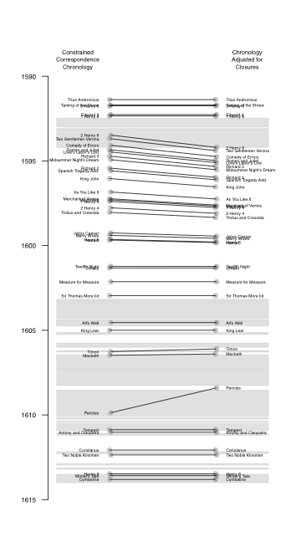

**Fig. 14.** Constrained correspondence analysis (CCA) chronology hand-fitted to playhouse Closings.(White = open; Gray = closed)**.**

Some remarks about this chronology are in order. Individual divergences from the Oxford order will and should produce debate: the early dates for *As You Like It*, and *Troilus and Cressida*, for instance, challenge received opinion about when these texts were composed. A much larger issue, however, concerns the late plays. Earlier we have mentioned Taylor's hypothesis regarding a "bend in the curve" of the linguistic data at about the time of *Coriolanus* (dated 1608 in the Oxford chronology). Our CCA is also confronted by results outside the range of expectations, results that might seem to call for some similar reassessment of the analysis's primary assumptions concerning Shakespeare's stylistic development. Two general possibilities come to mind. First is a version of Taylor's "bend in the curve" theory, in which--for reason or reasons not yet apparent--various tendencies in Shakespeare's compositional practice shift directions at about the time of *Coriolanus* (and *Pericles*, in our assessment). That is, that while the CCA appears to produce good (though not uncontroversial) results for the period 1590-1608, thereafter it is a questionable methodology for fixing chronology. Such a conclusion would seem to be called for in relation to external indications of date for *Cymbeline* (which Simon Forman saw prior to his death on 8 September 1611) and *Winter's Tale* (with two recorded performances in 1611); the entry of *Antony* *and Cleopatra* in the Stationers' Register on 20 May 1608 also asks us to question such an extremely late CCA dating (March 1611). Yet, accepting this argument, we would need to explain why the same CCA methodology produces a date for *The Two Noble Kinsmen* (September 1612) supported almost exactly by the PCA of the Tarlinskaja data, and only a few months earlier than the Oxford and Riverside chronologies. We would also need to explain why the bootstrap CCA produces a date of May 1613 for *Henry VIII*, the month before what we take to be its first performance at the Globe playhouse. If *Antony, Coriolanus*, *The Winter's Tale*, and *Cymbeline* are "too late," why do these collaborative plays finish so close to their conventionally accepted dates?

There is a chance that what the CCA is suggesting is correct about the *texts* of these late plays. That is--and this is a second possibility regarding the data--that what we are witnessing is a divergence between various external clues concerning when the titles in question were originally composed, and the makeup of the play texts as they appeared in the First Folio. Various things could explain this divergence, among them the possibility that Shakespeare revised these texts after their moment of initial composition. Such would account for the entry of *Antony*, and Forman's attendance at performances of *Winter's Tale* and *Cymbeline*: under this theory, these plays existed in earlier forms, and were revised by Shakespeare--perhaps in expanded, more "literary" form in anticipation of a larger collection of the plays.

**Conclusion [currently a laundry list--to be developed]**

1) we need a more flexible, understanding of Shakespeare's chronology. Such flexibility would acknowledge the certainty of diachronic composition--the writing, revising, transcription, and editing of texts. Instead of dating a play firmly, we might need to think and speak of "primary date of composition"

2) At the same time, we need ways of dating *parts* of Shakespeare's plays more precisely, especially when revision is concerned.

3) we need a method for dating Shakespeare's *prose*. Such might include (and not be limited to his prose) a sophisticated method of tracking his vocabulary, perhaps especially in relation to his reading

4) we need to understand the apparent (?) "bend in the curve" about the time of *Coriolanus*, something especially affecting the dating of the longer romances.

**References**

Greenacre, M., 2007. Correspondence Analysis in Practice, second ed. Chapman & Hall/CRC, London.

Groenen, P.J.F., and J. Poblome. 2003. Constrained correspondence analysis for seriation in archaeology applied to Sagalassos ceramic tablewares. In: Schwaiger, M., Opitz, O. (Eds.), Exploratory Data Analysis in Empirical Research. Springer, Berlin, pp. 90-97.

Lockyear, K. 2012. Applying bootstrapped Correspondence Analysis to archaeological data. Journal of Archaeological Science xx: 1-10.

MATLAB. 2011. Version 7.13.0. The MathWorks Inc. Natick, Massachusetts, USA.

Nenandic, O., and M. Greenacre. 2007. Correspondence analysis in R, with two- and three-dimensional graphics: The ca package. Journal of Statistical Software 20: 1-13.

Peeples, M.A., and G. Schachner. 2012. Refining correspondence analysis-based ceramic seriation of regional data sets. Journal of Archaeological Science 39: 2818-2827.

R Core Team. 2012. R: A language and environment for statistical computing. R Foundation for Statistical Computing, Vienna, Austria. http://www.R-project.org/.

Ringrose, T.J. 1992. Bootstrapping and Correspondence Analysis in Archaeology. Journal of Archaeological Science 19: 615-629.

van de Velden, M., P.J.F. Groenen, and J. Poblome. 2009. Seriation by constrained correspondence analysis: A simulation study. Computational Statistics and Data Analysis 53: 3129-3138.

ENDNOTES

1. (Charles Bathurst), *Remarks on the Differences in Shakespeare's Versification in Different Periods of his Life and on the Like Points of Differences in Poetry Generally*. (London: John W. Parker and Son, 1857), pp. 1, 6.
2. Saintsbury characterized Beaumont and Fletcher as "the first noteworthy examples of that 'unscrewing' of dramatic blank verse which led, before long, to the break-up of its whole structure as a dramatic medium." George Saintsbury, *A History of English Prosody: From the Twelfth Century to the Present Day*, 3 vols. (London: Macmillan and Co., 1906); vol. 2, p. 302. Shortly thereafter Saintsbury noted that Shakespeare "in his own later plays eased the screws very freely, and rather hazardously in appearance" (2: 303). In *Shakespeare's Verse: Iambic Pentameter and the Poet's Idiosyncrasies*, Marina Tarlinskaja observes that "the dramatic iambic pentameter of the Elizabethan-Jacobean epoch evolved from a more rigid to a looser form" (p. 44), returning to the metaphor of evolution on pp. 54, 82, and 218.
3. See ]bibl]
4. See ]bibl]
5. TC
6. Taylor, C&C
7. taylor
8. For this research, we have silently emended what appear to be a few typographical errors in Oras. For *All's Well*, C-Figures (p. 80), we have emended Oras's second "23" in the eighth position to "3" (which would square with his total, as well as with his percentages there); for Jonson's *The Case is Altered*, A-Figures (p. 66), the pause total should be 1058 (rather than Oras's 1048); we have used this figure to recalculate the percentages.
9. The characterization of Oras's research as "exhaustive" comes from George Wright (footnote).
10. figures for repeated tabulations--average variance Bruster/Oras
11. Tarlinskaja on Antony and Iago.
12. Taylor, *Textual Companion*, p. 132.
13. Oras himself analogized his pause pattern results to the output of a piece of medical technology that had come into general use during his lifetime: "the total patterns are likely to reveal much over which the person concerned has little or no control, almost as people are unable to control their cardiograms" (p. 2). Extending Oras's metaphor, we might say that his *Pause Patterns* monograph seeks to graph the heartbeat of iambic pentameter as it was manifested by a variety of texts written across a considerable number of years. Just as any individual's electrocardiographic results are likely to change over time (and, as Oras posits, not be under an individual's control), so do pause patterns develop in appreciable ways. By gathering this information, Oras puts himself and others in a position to trace verse's meaningful patterns--and, by extension, the formal careers of poets, genres, and cultures. The mechanical nature of such scholarship--at once its strength and weakness--has been noted by at least one observer. As Vincent Leitch has described Oras's work in another study, an inquiry into the manifestation of sound patterns in the poetry of Spenser and Milton, "It is rather like the study of subatomic particles, turning up new entities like neutrinos and quarks."
14. Oras does NOT provide a chronology.
15. C&C p. 107.
16. The problem of *2 Henry IV* coming "before" its prequel, in terms of metrical structure, has been noted by Henri Suhamy: "Il est inutile d'autre part de souligner longuement que les preuves internes que contient le texte de Shakespeare ne permettent pas de dater les oeuvres avec une précision reigoureuse. Si l'on se fiait aveuglément aux chiffres on en arriverait a affirmer que par exemple la seconde partie de *Henry IV* à pu être écrite avant la première." Suhamy, *Le Vers de Shakespeare* (Paris: Didier Erudition, 1984), p. 377. On some of the textual difficulties of *Pericles*, "the only play in the Shakespeare canon for which no comparatively authoritative text had survived," see G. Blakemore Evans in Evans ed., *The Riverside Shakespeare*, 2nd ed. (Boston: Houghton Mifflin, 1997), pp. 1559-60.
17. Jackson, p.
18. Jackson, p.
19. Jackson, p. 40.
20. Oras, p. 2.
21. note on self research--appendix
22. Oras and Jackson on Wilkins, ; add cite from Tarlinskaja.
23. jonson on pericles
24. The figures, with Shakespeare's percentage followed by his collaborator's in each case; greater figures in bold: *Edward III* **67.2**/60.5; *Titus Andronicus* 65/**66.25**; *Timon of Athens* **59.33**/57.6; *Pericles* 64.6/**72.1**; *The Two Noble Kinsmen* **58.6**/53.9; *Henry VIII* **56.1**/53.5. It should be pointed out that, among commercial plays of this era, Wilkins's percentage of even-numbered pauses in *Pericles* is rivaled by only a handful of highly rhythmical texts from the early 1590s, including Peele's *Battle of Alcazar*, Greene's *Orlando Furioso* and *James IV*, and Marlowe's *Massacre at Paris*. On the deeply iambic nature of Shakespeare's verse, see Dorothy Sipple,
25. Lowenstein on
26. Oras, p. 18. Oras notes that the busy dialogue of *The Alchemist* features 933 shared lines, the largest total he encountered in his survey.
27. see Oras on Fletcher
28. wages, prices, beliefs, ideology, practics. Kuhn, but economics generally.
29. Chambers, McManaway, Wentersdorf
30. Principal components analysis is a mathematical procedure used for exploring data and recognizing patterns. It has been employed successfully by such Shakespeare scholars as Jonathan Hope, Michael Whitmore, and MacDonald Jackson, among others.
31. Popularized in French sociology during the 1970s, correspondence analysis may be familiar to readers through the work of Pierre Bourdieu, among others. Bourdieu's *Distinction* (orig. pub. 1979) drew on this statistical methodology to map--literally, set out in tables and graphs--correlations among taste and social stratification. Thus "a situation of high economic capital and low cultural capital corresponds with a 'beautiful blue Danube' taste. Inversely, low economic capital and high cultural capital corresponds with a taste for abstract painting, Picasso and *The Well-tempered Clavier*" (BMS, 133).
32. CA archaeology studies
33. A precedent for this kind of correspondence analysis used for ordering texts exists in the work of Michael Greenacre, one of the statisticians responsible for bringing correspondence analysis to the attention of literary scholars. Greenacre's brief "Seriation of the Works of Plato" takes data relating to sentence endings in Plato's works and, performing a correspondence analysis, confirms the seriation b
34. These categories include data on: strong and weak syllabic positions, respectively; word boundaries (total and after positions); strong syntactic breaks; run-on lines; proclitic and enclitic stresses; syllabic -ed and -eth; disyllabic -ion; grammatical inversion; meter-sense; syntactical run-ons; feminine endings (total); feminine endings built by simple and compound constructions, respectively; and alliterative lines.
35. As You Like it bibl.
36. Jackson on STM.
37. See Appendix [X] for dates used to indicate open and closed periods for the commercial playhouses.
38. Barroll, *Politics, Plague*